Git merge
Master = c1, c2, c3
Feature = b1, b2, b3
Merge the code to master branch
Master = c1,c2,c3,c4
History not maintain b1,b2,b3 of merge code

git rebase
Maintain the history of commits
git checkout master
git rebase feature

Which branch you want to merge first move that branch
For ex
git checkout karthik
git branch –a
Currently karthik branch
git merge main

Git tags and release
Add the code in eclipse
git status
git add file path
git commit -m "feature 1"
git tag v1.0
git push origin v1.0
See the github in your repository release tag are created
add another code
git add file path
git commit -m "feature 2"
git tag v2.0
git push origin v2.0
add some code
git add file path
git commit -m "feature 3"
git tag v3.0
git push origin v3.0
See the github in your repository release tag are created
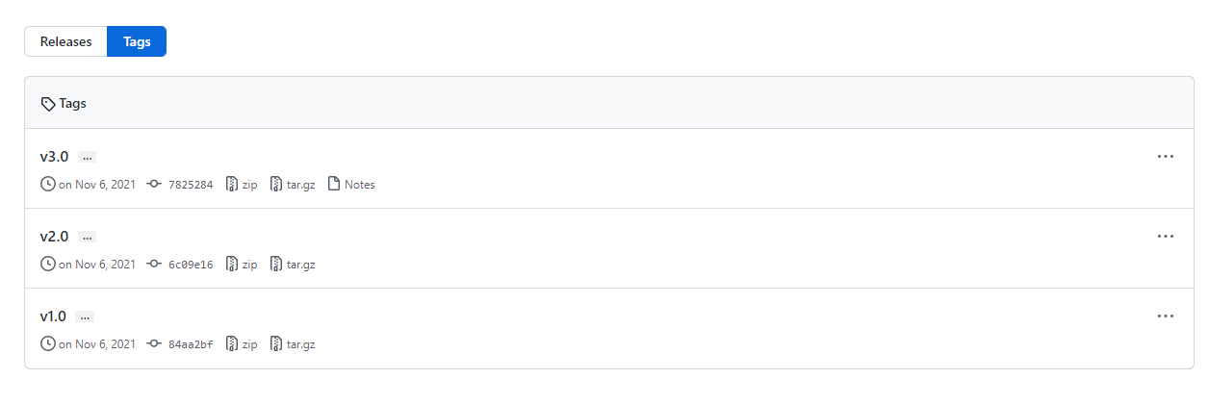
Click releases
Which tag you want to create release
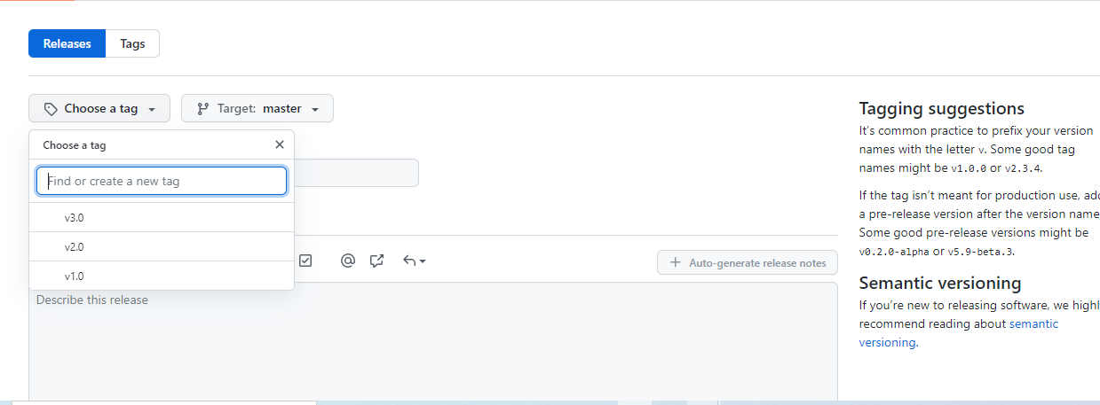
Add description
click save draft
click publish release
Go to tags->release tag->see the release tag and source code are attached
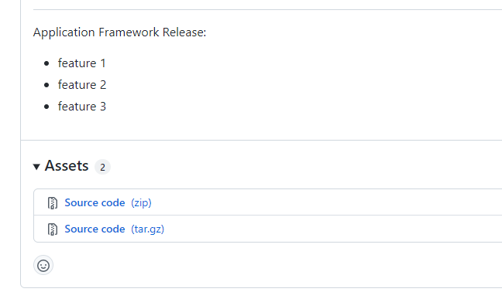
Delete tag in local repo
git tag
git tag -d v2.0

Git revert
add lines of code in eclipse
git status
git add file path
git commit -m "added print statement"
git log --oneline
git revert commitid
git log --oneline
Revert new commitId

git reset - soft, mixed, hard
Add code eclipse
git status
git add .
git commit -m "sample code"
git log --oneline
git reset --soft HEAD^
git status
Changes to be committed - Stage area - Removed commit area its available stage area
git commit -m "sample code 1"
git log --oneline

You want to remove the commit
git reset --soft HEAD^
git log --oneline

git commit -m "sample code 2"
git log –oneline

git reset --mixed HEAD^ = HEAD^ IS NOT BUT LAST COMMIT
git status
untracked files - >removed from stage and commit

You want to remove everything from working copy also (hard)
git add .
git commit -m "file path"
git logs --oneline
git reset --hard HEAD^
HEAD is now at 3es 43 (beware is delete working copy also)
git log --oneline
there is no commit
git status

After push remote repo what will happen when using "hard reset"
add code eclipse
git status
git add .
git commit -m "my last commit"
git status
(Code has been moved staged)
git push origin master
master->master
check the code in your repository
git reset --hard HEAD^ (remove from your working copy)
what to do next?
git status
nothing to commit, working tree clean
git push origin master
it becomes error either git pull and then git push
git push -f origin master
-f = forced to update
Check the code in Git hub repository its delete the code
its shows 404 error found

Git stash, merge conflict
Already update code in remote repo
Add code in master branch from local repo using eclipse
git checkout master
git status
git pull origin master
Aborting status
git stash
no local changes to save
git add .
git stash
saved working diretory and commit id
git log --oneline - check commit id
git pull origin master - pull latest code in remote repo
pull the code in remote repo
:q! -> save it
Check the code in working directory from eclipse
I have already saved my code using "stash" how to retrieve my code
git stash pop
merge conflict in "file path"
check the code in eclipse -> merge conflict happen
<<<<< ->coming from remote side
>>>>> - >coming from your local repo side
Discuss with developers which code need, we already my code and PR is approved
Remove this code
<<<<< ->coming from remote side - From eclipse editor
My code is ready and resolve to conflict and what to do "push the my code"

git status
new file shown after conflict resolved
git add file path
git commit -m "conflict resolved"
git push origin master
whatever changes is saved in local repo and well as remote repo
Refresh git hub repository

Other developers before doing
git pull origin master ->Pull the latest code from remote repo (what I have commit
latest)

git cherrypick
git checkout master
git add
git commit - 1 (commit ID)
git checkout -b develop
git add
git commit - 2 (commit ID)
git checkout master
add code
git commit - 3 (commit ID)
git checkout develop
add code
git commit - 4 (commit ID)
git checkout master
git cherry-pick 2 -> This one for develop branch commit ID
git logs --oneline
1
2
3
git checkout develop
git cherry-pick 1-> This one for master branch commit ID
git logs --oneline
2
4
1

